Task 2 — Multiple Sequence Alignment (CALHM Protein Family)

1. Input Information
Tool: Clustal Omega (1.2.4)
Sequences aligned: CALHM1 (Q8IU99), CALHM2 (Q9HA72), CALHM3 (Q86XJ0), CALHM4 (Q5JW98), CALHM5 (Q8N5C1)
Sequence type: Protein (canonical human)
Alignment length: ~360 amino acids

FASTA Sequences (UniProt canonical)

>sp|Q8IU99|CAHM1_HUMAN Calcium homeostasis modulator protein 1 OS=Homo sapiens OX=9606 GN=CALHM1 PE=1 SV=2
MMDKFRMIFQFLQSNQESFMNGICGIMALASAQMYSAFDFNCPCLPGYNAAYSAGILLAP
PLVLFLLGLVMNNNVSMLAEEWKRPLGRRAKDPAVLRYMFCSMAQRALIAPVVWVAVTLL
DGKCFLCAFCTAVPVSALGNGSLAPGLPAPELARLLARVPCPEIYDGDWLLAREVAVRYL
RCISQALGWSFVLLTTLLAFVVRSVRPCFTQAAFLKSKYWSHYIDIERKLFDETCTEHAK
AFAKVCIQQFFEAMNHDLELGHTHGTLATAPASAAAPTTPDGAEEEREKLRGITDQGTMN
RLLTSWHKCKPPLRLGQEEPPLMGNGWAGGGPRPPRKEVATYFSKV
>sp|Q9HA72|CAHM2_HUMAN Calcium homeostasis modulator protein 2 OS=Homo sapiens OX=9606 GN=CALHM2 PE=1 SV=1
MAALIAENFRFLSLFFKSKDVMIFNGLVALGTVGSQELFSVVAFHCPCSPARNYLYGLAA
IGVPALVLFIIGIILNNHTWNLVAECQHRRTKNCSAAPTFLLLSSILGRAAVAPVTWSVI
SLLRGEAYVCALSEFVDPSSLTAREEHFPSAHATEILARFPCKENPDNLSDFREEVSRRL
RYESQLFGWLLIGVVAILVFLTKCLKHYCSPLSYRQEAYWAQYRANEDQLFQRTAEVHSR
VLAANNVRRFFGFVALNKDDEELIANFPVEGTQPRPQWNAITGVYLYRENQGLPLYSRLH
KWAQGLAGNGAAPDNVEMALLPS
>sp|Q86XJ0|CAHM3_HUMAN Calcium homeostasis modulator protein 3 OS=Homo sapiens OX=9606 GN=CALHM3 PE=1 SV=2
MDKFRMLFQHFQSSSESVMNGICLLLAAVTVKLYSSFDFNCPCLVHYNALYGLGLLLTPP
LALFLCGLLANRQSVVMVEEWRRPAGHRRKDPGIIRYMCSSVLQRALAAPLVWILLALLD
GKCFVCAFSSSVDPEKFLDFANMTPSQVQLFLAKVPCKEDELVRDSPARKAVSRYLRCLS
QAIGWSVTLLLIIAAFLARCLRPCFDQTVFLQRRYWSNYVDLEQKLFDETCCEHARDFAH
RCVLHFFASMRSELQARGLRRGNAGRRLELPAVPEPPEGLDSGSGKAHLRAISSREQVDR
LLSTWYSSKPPLDLAASPGLCGGGLSHRAPTLALGTRLSQHTDV
>sp|Q5JW98|CAHM4_HUMAN Calcium homeostasis modulator protein 4 OS=Homo sapiens OX=9606 GN=CALHM4 PE=1 SV=1
MCPTLNNIVSSLQRNGIFINSLIAALTIGGQQLFSSSTFSCPCQVGKNFYYGSAFLVIPA
LILLVAGFALRSQMWTITGEYCCSCAPPYRRISPLECKLACLRFFSITGRAVIAPLTWLA
VTLLTGTYYECAASEFASVDHYPMFDNVSASKREEILAGFPCCRSAPSDVILVRDEIALL
HRYQSQMLGWILITLATIAALVSCCVAKCCSPLTSLQHCYWTSHLQNERELFEQAAEQHS
RLLMMHRIKKLFGFIPGSEDVKHIRIPSCQDWKDISVPTLLCMGDDLQGHYSFLGNRVDE
DNEEDRSRGIELKP
>sp|Q8N5C1|CAHM5_HUMAN Calcium homeostasis modulator protein 5 OS=Homo sapiens OX=9606 GN=CALHM5 PE=1 SV=1
MDAFQGILKFFLNQKTVIGYSFMALLTVGSERLFSVVAFKCPCSTENMTYGLVFLFAPAW
VLLILGFFLNNRSWRLFTGCCVNPRKIFPRGHSCRFFYVLGQITLSSLVAPVMWLSVALL
NGTFYECAMSGTRSSGLLELICKGKPKECWEELHKVSCGKTSMLPTVNEELKLSLQAQSQ
ILGWCLICSASFFSLLTTCYARCRSKVSYLQLSFWKTYAQKEKEQLENTFLDYANKLSER
NLKCFFENKRPDPFPMPTFAAWEAASELHSFHQSQQHYSTLHRVVDNGLQLSPEDDETTM
VLVGTAHNM

2. Alignment Overview
The MSA shows highly conserved regions across the CALHM family, particularly within transmembrane domains. Symbols in the alignment: '*' indicates fully conserved residues, ':' indicates strong similarity, and '.' indicates weak similarity. Several key motifs are preserved, such as the conserved Cys-Pro-Cys (CPC) region characteristic of calcium channel proteins.
• The N-terminal and transmembrane regions show strong conservation across all members.
• CALHM1 and CALHM3 share the highest sequence similarity (~70–75% identity).
• CALHM2, CALHM4, and CALHM5 form a separate subgroup with lower sequence identity (~40–50%).
• Divergence increases toward the C-terminal domain, suggesting functional specialization.

Figures
Figure 1. Colored multiple sequence alignment (Clustal color scheme).
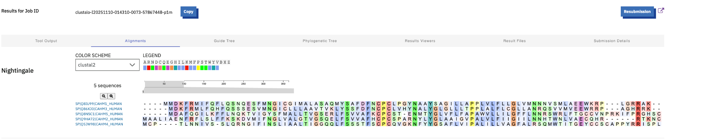

Figure 2. CLUSTAL text alignment with consensus symbols (* : .).

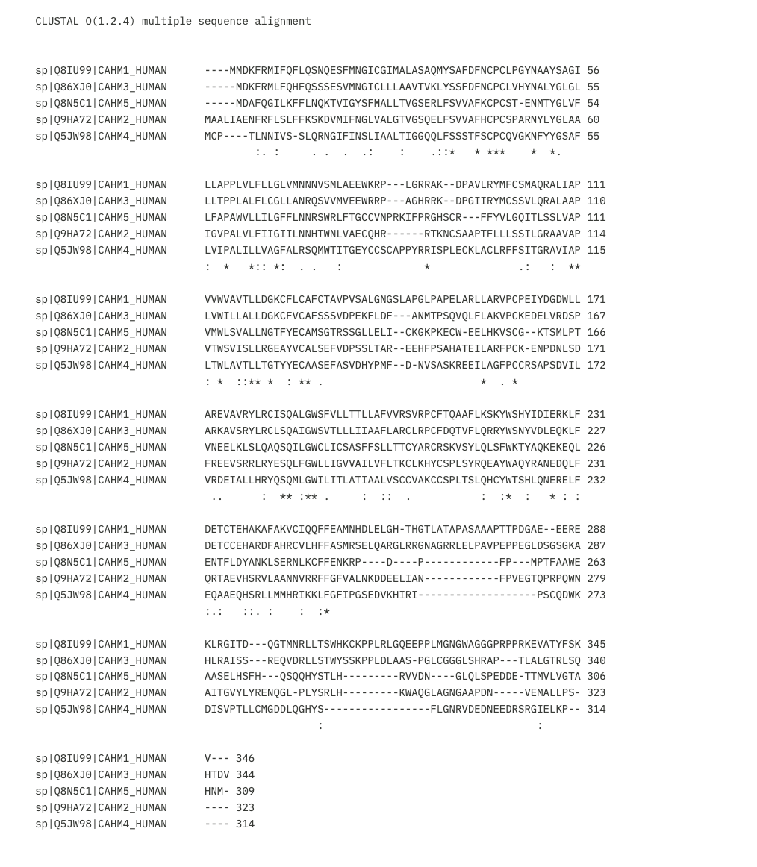

Figure 3. Guide tree (UPGMA/Neighbor-joining as rendered by Clustal Omega).
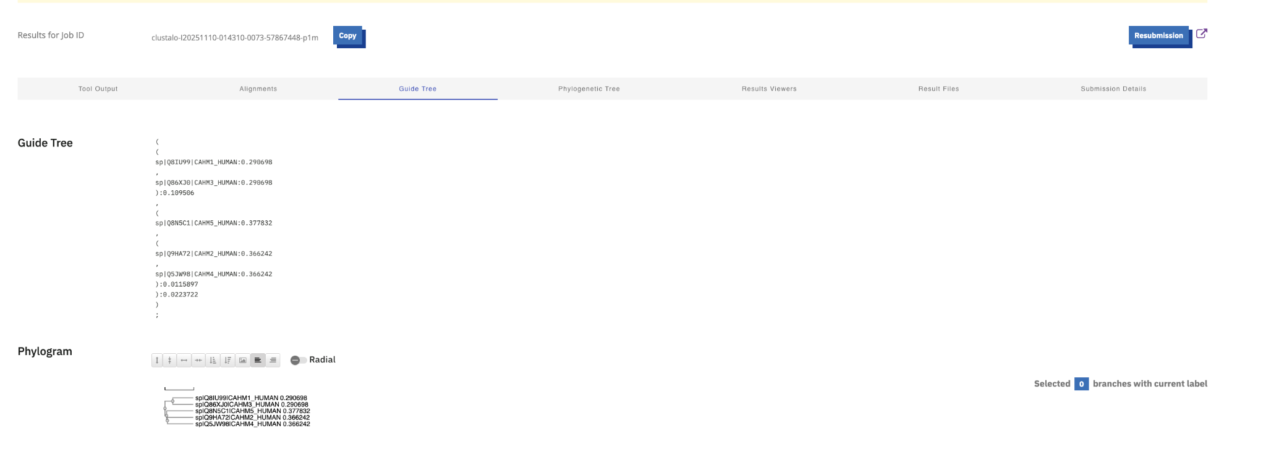

3. Guide Tree & Phylogenetic Relationships
The generated guide tree indicates two major clusters within the human CALHM protein family:
(CALHM1_HUMAN, CALHM3_HUMAN) form a sister clade with the closest evolutionary relationship. (CALHM5_HUMAN, (CALHM2_HUMAN, CALHM4_HUMAN)) form the second clade, representing more divergent paralogs.
This topology supports existing literature suggesting that CALHM1 and CALHM3 functionally cooperate in neuronal calcium signaling, while CALHM2–5 are expressed in broader tissues with potential hetero-oligomerization.

4. Key Observations
• Conserved hydrophobic segments correspond to transmembrane helices vital for pore formation.
• The CPC motif is strictly conserved, reinforcing its role in Ca2+ permeability.
• Cys-rich loops suggest disulfide bond stabilization across homologs.
• The C-terminal regions exhibit higher variability, aligning with subfunctional diversification.

5. Conclusion
Overall, the MSA reveals strong conservation within the CALHM protein family, highlighting structural and functional homology. CALHM1 and CALHM3 share the highest similarity, forming a close evolutionary pair, while CALHM2–5 represent a distinct yet related group. These insights corroborate the classification of CALHMs as transmembrane Ca2+-permeable channels with varying tissue distributions.

